***API*** ***Assignment Questions***

1. **Explain the following:**
2. PUT and PATCH methods

**PUT**: Updates the entire resource. Replaces existing data with new data.

**PATCH**: Partially updates the resource. Only changes specified fields.

1. Headers and Cookies

**Headers**: Metadata sent with HTTP requests and responses (e.g. Content-Type, Authorization).

**Cookies**: Small pieces of data stored on the client side and sent with requests for session management.

1. Endpoint and Base URL

**Base URL**: The root address for an API.

**Endpoint**: The specific path to access a resource

1. Query Parameters and Path Parameters

**Path Parameter**: Part of the URL path (e.g., /users/2 in this url, 2 is a path parameter).

**Query Parameter**: Key-value pairs added after ? in a URL

1. What are error codes? Explain all series of error codes.

Error codes are HTTP status codes indicating response status.

* **1xx** — Informational
* **2xx** — Success (200 OK, 201 Created)
* **3xx** — Redirection
* **4xx** — Client Errors (404 Not Found, 400 Bad Request)
* **5xx** — Server Errors (500 Internal Server Error)

Create a new collection in Postman named "Sample APIs." Use https://reqres.in/ and implement GET, POST, PUT, PATCH, and DELETE operations.

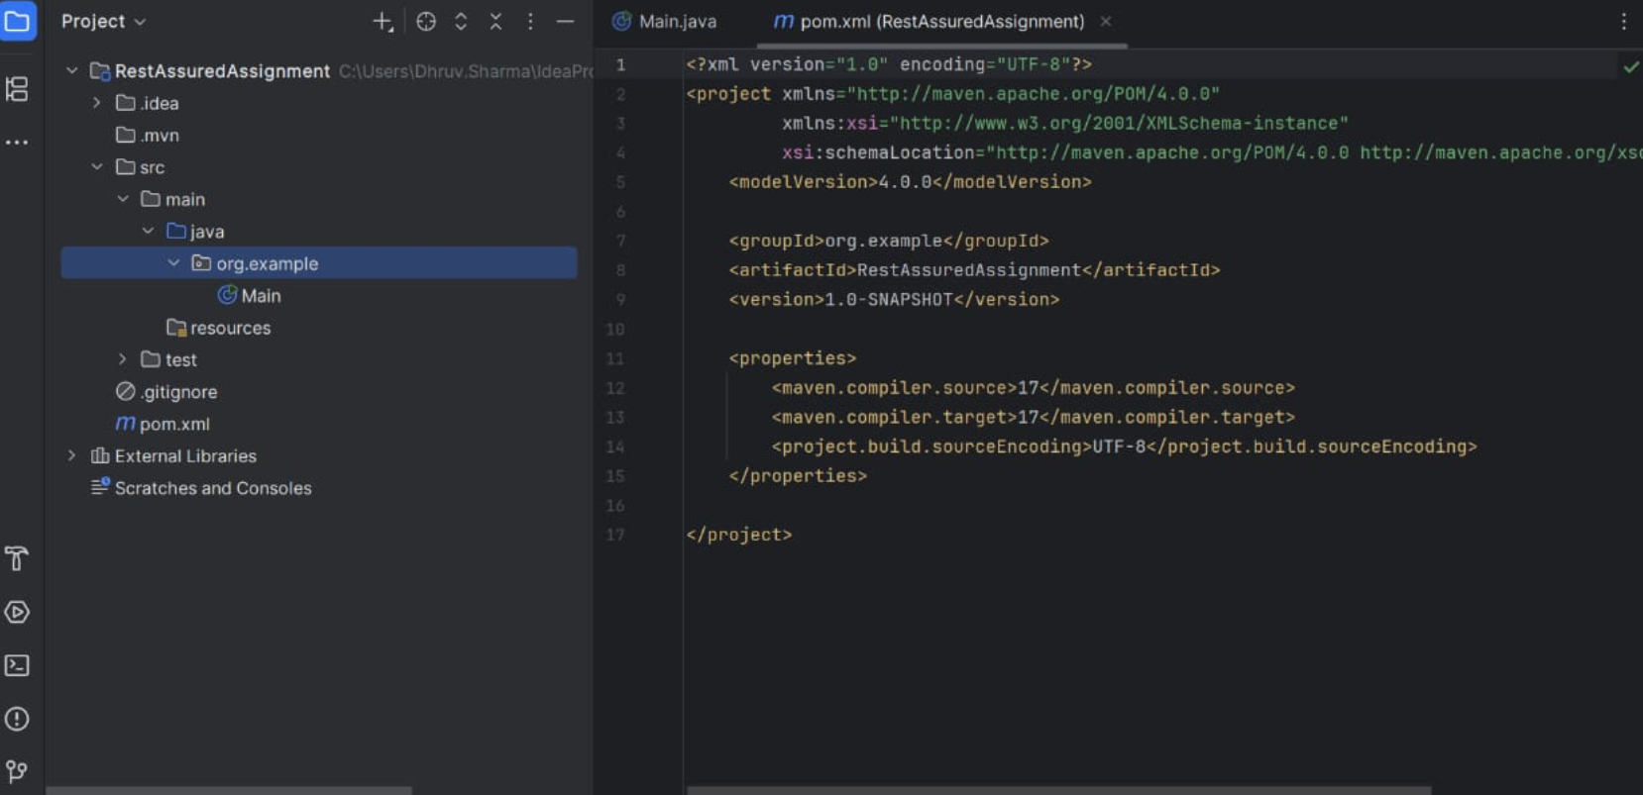

What is the difference between given(), when(), and then() in Rest Assured?

**given()** is used to set up the preconditions for the request. It is where you define headers, parameters, authentication details, request body, and content type.

**when()** is used to specify which HTTP request method (such as GET, POST, PUT, DELETE) will be used and to mention the endpoint URL. It represents the action being performed.

**then()** is used to validate the response after sending the request. You can check status codes, response body content, response time, and other response-related validations.

* given() prepares the request.
* when() sends the request.
* then() validates the response.

1. **Perform the operations with Rest Assured (use** [**https://reqres.in/**](https://reqres.in/)**):**
2. Create GET, POST, PUT, PATCH, and DELETE
3. Assert for 200/201 response
4. Verify “first_name” key value from GET response
5. Extract “email” from GET request and add it to the subsequent POST request payload and hit the request
6. Write a function to verify presence of Message in response body

